**Drafted by:**

Megan diamond

Feathers Environmental Services

P.O. Box 786962, Sandton, 2146

megandiamond7@gmail.com

**Prepared for:**

Mandara Consulting Solutions (Pty) Ltd

PO Box 3203, Rivonia, 2128

mandaraconsulting@gmail.com

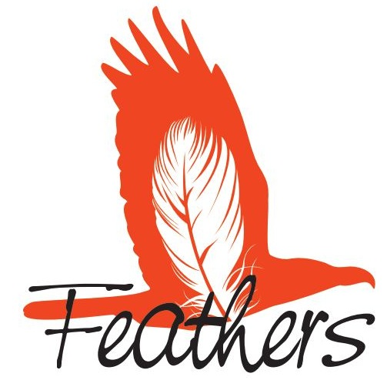

**Masa-Ngwedi Avifaunal EMP D**

Construction & operational environmental management plan for the masa ngwedi 765kv & 400kv power lines

JANUARY 2014

## **declaration of independence**

I, **Megan Diamond**, in my capacity as a specialist consultant, hereby declare that I:

* Act as an independent specialist for this project.
* Do not have any personal or financial interest in the project except for financial compensation for specialist investigations completed in a professional capacity as specified by the Environmental Impact Assessment Regulations, 2010.
* Will not be affected by the outcome of the environmental process, of which this report forms part of.
* Do not have any influence over the decisions made by the governing authorities.
* Do not object to or endorse the proposed developments, but aim to present facts and our best scientific and professional opinion with regard to the impacts of the development.
* Undertake to disclose to the relevant authorities any information that has or may have the potential to influence its decision or the objectivity of any report, plan, or document required in terms of the Environmental Impact Assessment Regulations, 2010.

## **professional experience**

Megan has been involved in conservation for 15 years and holds a BSc in Environmental Management. She has seven years experience in the field of bird interactions with electrical infrastructure. In various roles (including Programme Manager) with the Endangered Wildlife Trust’s Wildlife & Energy Programme and the Programme’s primary project (Eskom-EWT Strategic Partnership) from 2006 to 2013, Megan was responsible for assisting the energy industry and the national utility in minimising the negative impacts (associated with electrical infrastructure) on wildlife through the provision of strategic guidance, risk and impact assessments, training and research.

Megan is a co-author of various papers related to bird and power line interactions as well as the *BirdLife South Africa / Endangered Wildlife Trust best practice guidelines for avian monitoring and impact mitigation at proposed wind energy development sites in southern Africa* and the *Avian Wind Farm Sensitivity Map for South Africa* and played an instrumental role in facilitating the endorsement of these two products by the South African Wind Energy Association (SAWEA), IAIAsa (International Association for Impact Assessment South Africa) and Eskom. In 2011/2012, Megan chaired the Birds and Wind Energy Specialist Group in South Africa.

## **indemnity**

* This report is based on survey and assessment techniques which are limited by time and budgetary constraints relevant to the type and level of investigation undertaken.
* This report is based on a desktop investigation using the available information and data related to the site to be affected and a one day site visit to the study area in January 2014. No long term investigation or monitoring has been conducted.
* The Precautionary Principle has been applied throughout this investigation.
* The findings, results, observations, conclusions and recommendations given in this report are based on the author’s best scientific and professional knowledge as well as available information at the time of study.
* Additional information may become known or available during a later stage of the process for which no allowance could have been made at the time of this report.
* The specialist investigator reserves the right to modify this report, recommendations and conclusions at any stage should additional information become available.
* Information, recommendations and conclusions in this report cannot be applied to any other area without proper investigation.
* This report, in its entirety or any portion thereof, may not be altered in any manner or form or for any purpose without the specific and written consent of the specialist investigator as specified above.
* Acceptance of this report, in any physical or digital form, serves to confirm acknowledgment of these terms and liabilities.

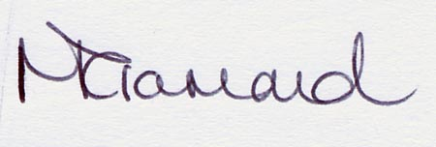

14 January 2014

**Table of Contents**

1. **INTRODUCTION 4**
2. **STUDY METHODOLOGY 4**

**2.1 Terms of Reference 4**

**2.2 Approach** **4**

**2.3 Data Sources Used 5**

**2.4 Relevant Legislation & Guidelines** **5**

**2.5 Limitations & Assumptions 6**

1. **BACKGROUND TO THE STUDY 8**
2. **GENERAL DESCRIPTION OF BIRD INTERACTIONS WITH ELECTRICAL INFRASTRUCURE 10**

**4.1 Electrocutions 11**

**4.2 Collisions 11**

**4.3 Habitat Destruction 12**

**4.4 Disturbance 12**

**4.5 Impact on the quality of supply 13**

**4.6 Nesting 13**

1. **MITIGATION 14**

**5.1 Electrocutions on the power line infrastructure 14**

**5.2 Collisions with the overhead cables 14**

**5.3 Habitat destruction during construction & operational activities 14**

**5.4 Disturbance during construction & operational activities 14**

**5.5 Impact on the quality of the electrical supply 15**

**5.6 Nesting 15**

1. **SITE SPECIFIC mitigation recommendations 16**
2. **responsibilities 17**
3. **penalties 17**
4. **references 17**

## **introduction**

Eskom Transmission received a positive Record of Decision from the Department of Environment Affairs to construct the new Masa-Ngwedi 765kV and Masa-Ngwedi 400kV power lines. As a special condition, the Department requested that Eskom submit an Environmental Management Plan (EMP) to the Department for approval before any commencement of the abovementioned activities. In line with environmental legislation, Eskom Transmission has appointed Mandara Consulting Solutions (hereafter referred to as Mandara) as independent consultants to conduct and compile the necessary EMP for the development, traversing the Limpopo and North West Provinces between Masa substation (near Lephalale in the Limpopo Province) and Ngwedi substation (situated near Sun City in the North West Province). The total length of the lines is approximately 80km. Feathers Environmental Services was appointed by Mandara to compile a specialist avifaunal construction EMP report based on a desktop review and a one-day site visit (conducted on 11 January 2014) of the avifaunally sensitive areas within the study area. This report highlights the constraints with regards to the construction and operation of the new power lines and provides recommendations for the mitigation of these. The recommendations provided in this report are specific to the first 40km of the route i.e. towers 259-340 (765kV) and 253-326 (400kV).

## **Study methodology**

* 1. **Terms of Reference**

The avifaunal specialist has conducted this assessment according to the following terms of reference, supplied by Mandara.

* Review existing literature on the avifaunal species on the approved corridor.
* Assess each tower position
* Identify avifaunal related impacts, their location and significance, and recommend suitable mitigation measures

**2.2 APPROACH**

This assessment followed the following steps:

* A review of available literature pertaining to bird interactions with power line infrastructure.
* The various data sets listed below and the study area were examined at a desktop level to determine the likelihood of bird:power line interactions.
* Avifaunally sensitive areas along the route alignment, where the above impacts are likely to occur, were identified using various GIS (Geographic Information System) layers, Google Earth imagery and personal observations made during the site visit.
* Recommendations are made for the management and mitigation of impacts.

## **2.3 Data sources used**

The following data sources and reports were used in varying levels of detail for this study:

* Satellite Imagery of the area was studied using Google Earth ©2013.
* Electronic 1:50 000 maps were obtained from the Surveyor General.
* Delta Epsilon Impact Assessment Report – Avifaunal Specialist Report and Appendices dated August 2009.
* Masa Ngwedi EMP D Draft Wetland Input Report dated November 2013.
* Masa Ngwedi EMP D Vegetation Input Report dated November 2013.
* Vulture movement data for the area received from VULPRO, dated January 2014
* The power line - bird mortality incident database of the Eskom/Endangered Wildlife Trust Strategic Partnership (1996 to present) was consulted to determine which of the species occurring in the study area are typically impacted upon by power lines, and the extent of the impact.
* KMZ. shapefiles detailing tower positions were obtained from Mandara.

## **Relevant legislation and guidelines**

The relevant legislation to this specialist field and development are as follows:

* The Convention on Biological Diversity: dedicated to promoting sustainable development. The Convention recognizes that biological diversity is about more than plants, animals and micro-organisms and their ecosystems – it is about people and our need for food security, medicines, fresh air and water, shelter, and a clean and healthy environment in which to live. It is an international convention signed by 150 leaders at the Rio 1992 Earth Summit. South Africa is a signatory. An important principle encompassed by the CBD is the precautionary principle which essentially states that where serious threats to the environment exist, lack of full scientific certainty should not be used a reason for delaying management of these risks. The burden of proof that the impact will *not* occur lies with the proponent of the activity posing the threat.
* The Convention on the Conservation of Migratory Species of Wild Animals (also known as CMS or Bonn Convention) aims to conserve terrestrial, aquatic and avian migratory species throughout their range. It is an intergovernmental treaty, concluded under the aegis of the United Nations Environment Programme, concerned with the conservation of wildlife and habitats on a global scale. Since the Convention's entry into force, its membership has grown steadily to include 117 (as of 1 June 2012) Parties from Africa, Central and South America, Asia, Europe and Oceania. South Africa is a signatory.
* The Agreement on the Conservation of African-Eurasian Migratory Water birds (AEWA) is the largest of its kind developed so far under the CMS. The AEWA covers 255 species of birds ecologically dependent on wetlands for at least part of their annual cycle, including many species of divers, grebes, pelicans,

cormorants, herons, storks, rails, ibises, spoonbills, flamingos, ducks, swans, geese, cranes, waders, gulls, terns, tropic birds, auks, frigate birds and even the South African penguin. The agreement covers 119 countries and the European Union (EU) from Europe, parts of Asia and Canada, the Middle East and Africa.

* The National Environmental Management – Biodiversity Act - Threatened or Protected Species list (TOPS).
* Various sets of provincial conservation legislation are also relevant to this study.

## **2.5 Limitations & assumptions**

The specialist was unable to access all areas of the study site, during the one-day site visit to the study area on 11 January 2014 and could therefore not assess each tower position (FIGURES 1 and 2). As a result, primary information on bird species presence, movement and breeding activities along the route alignment could not be collected for each tower position. The specialist was however able to confirm various habitat types that are capable of supporting bird species of conservation importance. Based on these findings, the specialist was able to provide recommendations for mitigation.

Predictions in this study are based on experience of these and similar species in different parts of South Africa, through the authors’ experience working in the avifaunal specialist field since 2006. However bird behaviour can’t be reduced to formulas that will hold true under all circumstances.

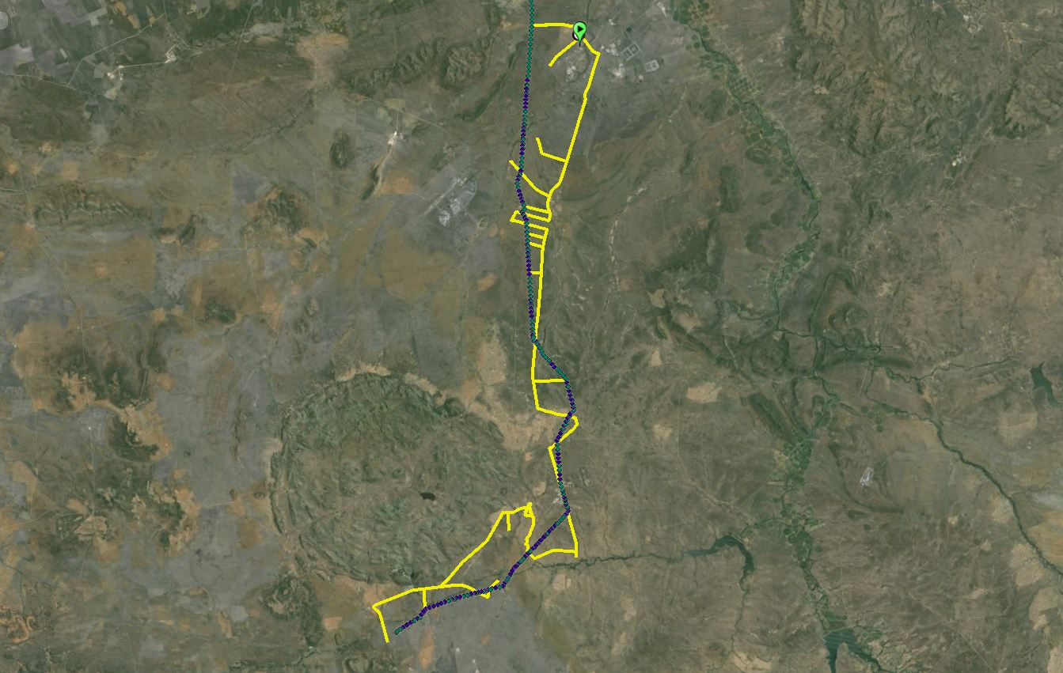

**FIGURE 1:** Track log of the site visit conducted on 11 January 2014

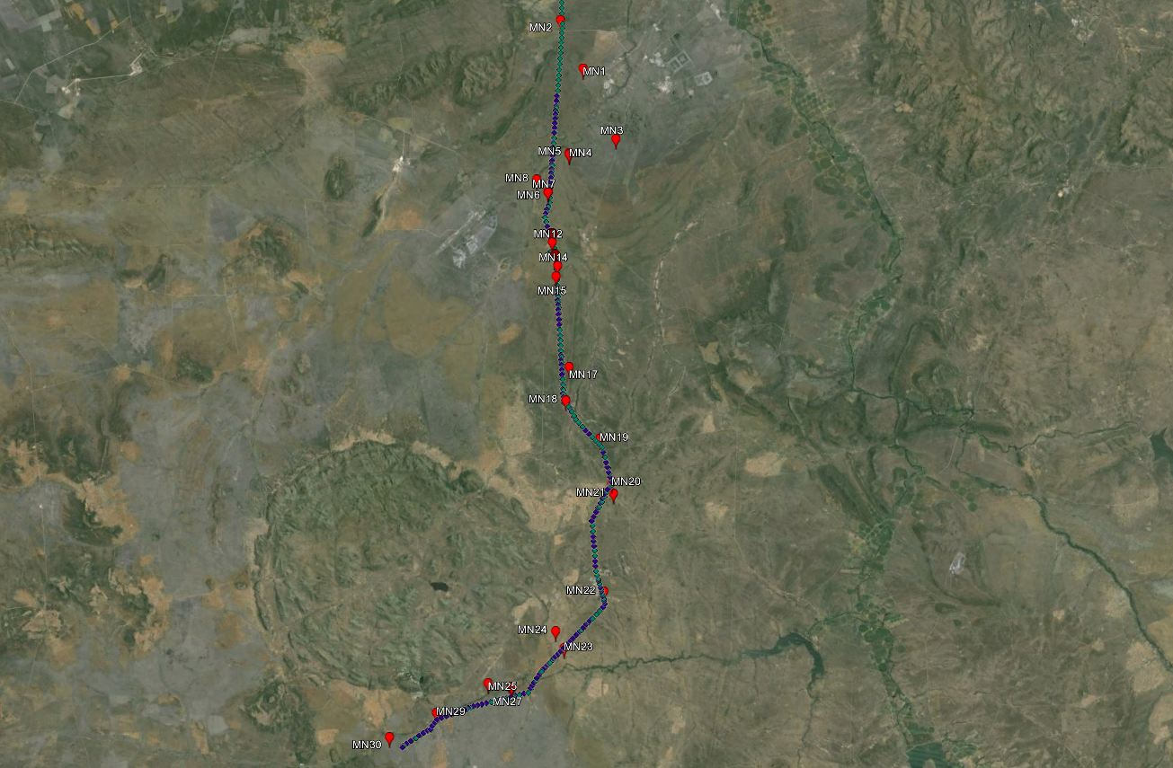

**FIGURE 2:** Survey points (red markers) along the Masa Ngewdi 765kV & 400kV route alignments

1. **background to the study**

This report covers the section of the proposed Masa Ngwedi power line infrastructure that starts at towers 259 (765kV) and 253 (400kV) and ends with the towers 340 (765kV) and 326 (400kV). The start of the proposed power line section is located west of the R510 and approximately 5km south west of the town of Thabazimbi. The approximate starting coordinates are 24°50'12.58"S and 27°14'11.04"E. The end of the proposed line is located east of the R510 and approximately 3.5km north of the town of Sandfontein. The approximate coordinates are 25° 8'40.81"S and 27°16'47.99"E. The proposed line is aligned south for the majority of the line and south east the final section.

While much of the distribution and abundance of the bird species in the study area can be explained by the description of vegetation types, it is even more important to examine the micro habitats available to birds. These micro habitats are formed by a combination of factors such as vegetation, land use, anthropogenic factors, topography and others and are critically important in mapping the site in terms of avifaunal sensitivity and ultimately informing the mitigation requirements at each tower position. The micro habitats identified and confirmed on, or within close proximity to, this first section of the route alignments include rivers and drainage lines, agriculture (dryland cultivation), fallow fields, thicket and woodland (FIGURE 3). The importance of these micro habitats to the avifaunal community is described in detail in the avifaunal impact assessment report.

Towers 266-282 (765kV) and 259-273 (400kV) traverse directly through the Northern Turf Thornveld Important Bird Area (SA009), an area that consists of a series of privately owned farms, which are characterised by flat plains holding black vertic clays derived from basalt. This area holds the core of the remaining resident South African population of Yellow-throated Sandgrouse *Pterocles gutturalis*. The sandgrouse inhabit short open grassland, fallow fields and recently burnt ground, especially on black clay soils near water. Other Red Data species recorded in this area include Cape Vulture *Gyps coprotheres*, Lappet-faced Vulture *Aegypius tracheliotos*, Martial Eagle *Polemaetus bellicosus*, Kori Bustard *Ardeotis kori*, Pallid Harrier *Circus macrourus*, Black-winged Pratincole *Glareola nordmanni*, Secretarybird *Sagittarius serpentarius* and Lanner Falcon *Falco biarmicus*, all of which are susceptible to interactions with power lines.

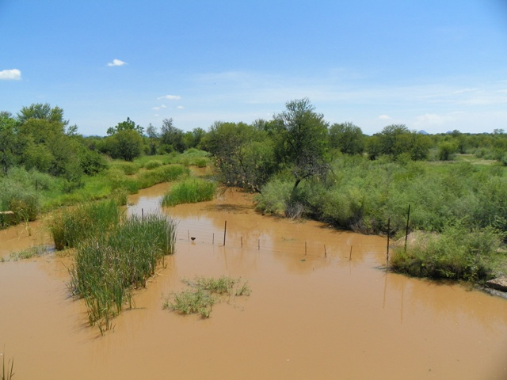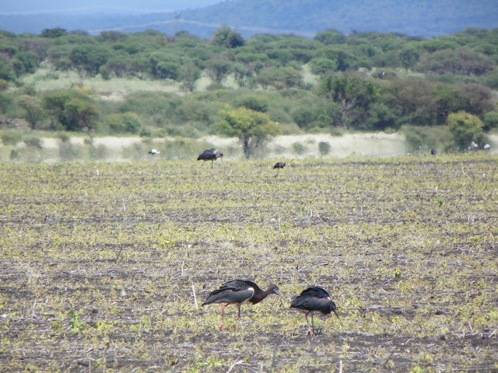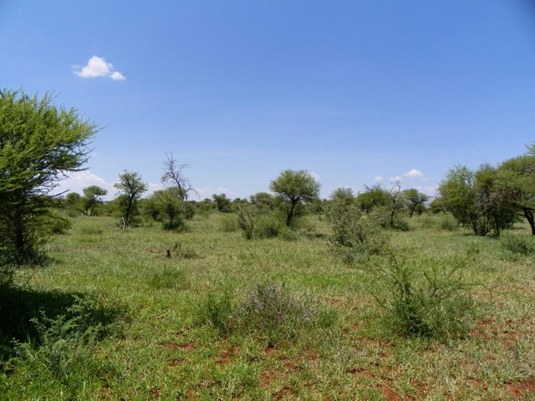

**FIGURE 3:** Examples of the micro habitat types (rivers, thicket and woodland, agricultural lands) identified and confirmed along the route alignments.

1. **GENERAL DESCRIPTION OF BIRD INTERACTIONS WITH ELECTRICAL INFRASTRUCURE**

Because of their size and prominence, electrical infrastructures constitute an important interface between wildlife and man. Negative interactions between wildlife and electricity structures take many forms, but two common problems in southern Africa are electrocution of birds (and other animals) and birds colliding with power lines (Ledger & Annegarn 1981; Ledger 1983; Ledger 1984; Hobbs & Ledger 1986a; Hobbs & Ledger 1986b; Ledger, Hobbs & Smith, 1992; Verdoorn 1996; Kruger & Van Rooyen 1998; Van Rooyen 1998; Kruger 1999; Van Rooyen 1999; Van Rooyen 2000). Other problems are electrical faults caused by bird excreta when roosting or breeding on electricity infrastructure, (Van Rooyen & Taylor 1999) and disturbance and habitat destruction during construction and maintenance (operational) activities.

**4.1 ELECTROCUTIONS**

Electrocution refers to the scenario where a bird is perched or attempts to perch on the electrical structure and causes an electrical short circuit by physically bridging the air gap between live components and/or live and earthed components (van Rooyen 2004). Due to the large size of the clearances on most overhead lines of above 132kV, electrocutions are generally ruled out as even the largest birds cannot physically bridge the gap between dangerous components. It can be concluded that electrocutions on both new Masa Ngwedi 765kV and 400kV power lines will not be possible through conventional mechanisms.

**4.2 collisions**

Collisions are the biggest single threat posed by transmission lines to birds in southern Africa (van Rooyen 2004). Most heavily impacted upon are bustards, storks, cranes and various species of waterbirds. These species are mostly heavy-bodied birds with limited manoeuvrability, which makes it difficult for them to take the necessary evasive action to avoid colliding with power lines (van Rooyen 2004, Anderson 2001).

Relevant to this development, collisions are likely to be linked to specific habitat types and/or specific sets of circumstances. The following high collision potential scenarios, potentially involving Red Data species, present themselves in the study area:

* + Proximity of breeding Red Data raptors and vultures to the proposed power lines. In this scenario the young, recently fledged birds would be most at risk of collisions. Species typically at risk would be White-backed Vulture *Gyps africanus*, Martial Eagle, Lappet-faced Vulture and Tawny Eagle *Aquila rapax* in the woodland biome.
  + Lines crossing or skirting old and fallow lands, and patches of natural grassland in commercial farming areas in the woodland biome. Red Data species at risk here are mostly Kori Bustard and Secretarybird.
  + Lines crossing relatively isolated agricultural fields surrounded by natural woodland, are also important for other large terrestrial species, in particular the migratory White Stork *Ciconia ciconia*, and Abdim’s Stork

*Ciconia abdimii*. Large numbs of White, Abdim’s and Marbou storks were observed in an agricultural field alongside the R510 national road during the site visit to the area (FIGURE 3).

* + Lines crossing rivers. These are important habitat for a variety of Red Data species, and the constant movement of birds up and down the river in search of food creates a collision risk. Species at risk are Yellow-billed Stork *Mycteria ibis*, Black Stork *Ciconia nigra*, Marabou Stork *Leptoptilos crumeniferus*, and White-backed Night Heron *Gorsachius leuconotus*.
  + Vultures feeding on a carcass in close proximity to the proposed lines. Vultures descending to a carcass are at risk of collisions with a nearby power line. Birds will also be at risk when rapidly taking off at the carcass if disturbed by people or mammalian predators.
  + Vultures have taken to roosting and perching (sometimes overnight) on the existing 400kV transmission infrastructure in close proximity to the Masa Ngwedi 765kV and 400kV power lines (FIGURE 4 - Phipps *et al,* 2013). Camera trap footage of two 400kV power lines traversing across the Rhino & Lion Park located in the Cradle of Humankind, revealed that the vultures roost on the earth peaks and are flying extremely close to the earth wires when landing and taking off from the earth peaks (Smallie & Strugnell, 2011). It is highly likely that the vultures in the study area are behaving in a similar manner, resulting in them being vulnerable to collisions with the new Masa Ngwedi 765kV and 400kV overhead earth wires.

It is a proven fact that placing a new transmission power line next to an existing transmission power line reduces the risk of collisions to birds. The reasons for that are two-fold, namely it creates a more visible obstacle to birds and the resident birds, particularly breeding adults, are used to an obstacle in that geographic location and have learnt to avoid it (APLIC 1994; Sundar & Choudhury 2005). Although sections of the Masa Ngwedi 765kV and 400kV power line alignments being assessed in this report are located parallel to existing 400kV infrastructure and the likelihood of adult bird collisions may be reduced, juvenile collisions cannot be discounted. Young birds are extremely clumsy fliers and have not yet learned to avoid the many anthropogenic obstacles (i.e. power lines) in their landscape and are therefore highly susceptible to collisions with the overhead earth wires.

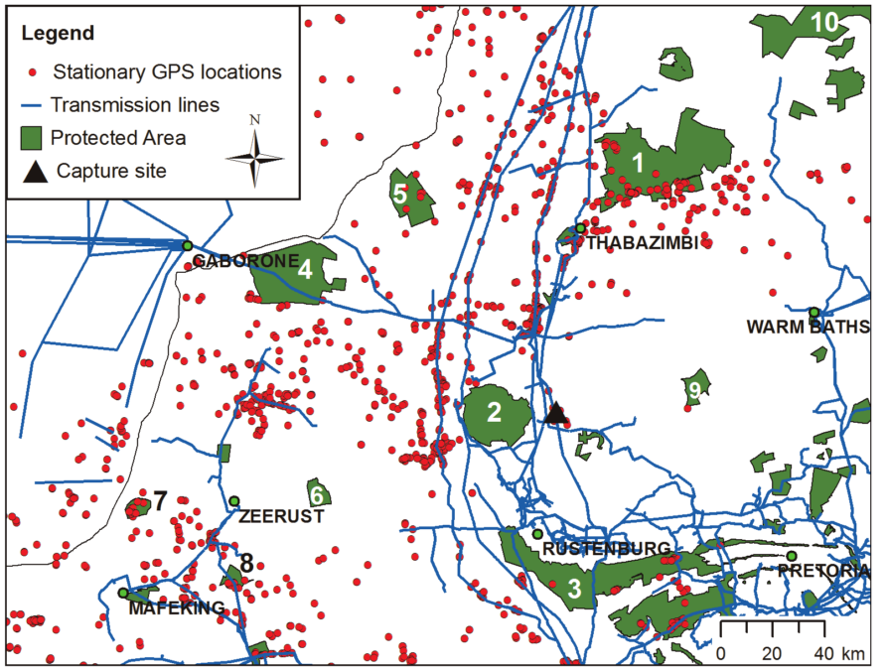

**FIGURE 4:** Stationary GPS locations in relation to protected areas and transmission power lines in the northern provinces of South Africa (Phipps *et al*, 2013).

**4.3 HABITAT DESTRUCTION**

During the construction phase of power lines and substation yards, some habitat destruction and alteration inevitably takes place. This happens with the construction of access roads, the clearing of servitudes and the levelling of substation yards. These activities have an impact on birds breeding, foraging and roosting in or in close proximity of the servitude through modification of habitat. The effect of the vegetation clearing will be more marked in the woodland biome, where the clearing of the servitudes would necessitate the removal of woody plants, and especially large trees. The new line will undoubtedly destroy and modify a certain amount of habitat. However at a landscape level, is it unlikely to have a major impact on Red Data species.

**4.4 DISTURBANCE**

Similarly, the above mentioned construction activities impact on bird through disturbance, particularly during breeding activities. This could lead to breeding failure if the disturbance happens during a critical part of the breeding season. The disturbance that will be caused by the construction activities will be temporary and should not lead to species being permanently displaced from the area. However, in the case of large, sensitive species, particularly large raptors and vultures, this might lead to permanent displacement.

**4.5 IMPACT ON THE QUALITY OF SUPPLY**

Through the mechanisms described below, birds are able to cause electrical faults on power lines. The more faults that occur on a line, the poorer the quality of electrical supply to the end customers.

In the case of a bird streamer induced fault, the fault is caused by the bird releasing a “streamer” of faeces which can constitute an air gap intrusion between the conductor and the earthed structure. The fault appears to flash across the air gap and *does not* follow an insulator creepage path as observed on pollution faults (See Taylor *et al* 1999 for an exhaustive analysis of the propagation characteristics of the bird streamer mechanism).

Bird pollution is a form of pre-deposit pollution. A flashover occurs when an insulator string gets coated with pollutant, which compromises the insulation properties of the string. When the pollutant is wetted, the coating becomes conductive, insulation breakdown occurs and a flashover results.

Both bird streamers and bird pollution occur as a result of birds perching on pylons or towers, often directly above live conductors. The cross rope suspension towers have no suitable perching space above the conductors, so impact on quality of supply through streamers by birds is not anticipated. It is also important to note that there have been no previous reports of streamer induced faulting on 765kV power lines due to the large size of the clearances (pers. comms. Hein Vosloo).

**4.6 NESTING & ROOSTING**

Transmission power lines have proven to be beneficial to many birds, including species such as Southern Bald Ibis *Geronticus calvus*, Martial Eagle, Tawny Eagle, White-backed Vulture, and even occasionally Verreaux’s Eagles *Aquila verreauxii* by providing safe nesting and roosting sites in areas where suitable natural alternatives are scarce (van Rooyen 2004). Reports by landowners confirm that Cape and White-backed Vultures have taken to roosting on power lines in the study area e.g. at Mogwase near Pilanesberg, and elsewhere. Opportunistic power line roosting is also common where the birds have fed on a carcass.

The self-support tower has proven a very suitable nesting structure for certain bird species. This may have implications for quality of supply on these transmission power lines, particularly as far as crows are concerned, as they often use wires as part of their nest material. The cross rope suspension tower has much less suitable nesting space, and if used by crows or other nesting species, they will nest within the vertical columns and this will pose no risk to quality of supply.

1. **MITIGATION**

**5.1 ELECTROCUTIONS ON THE POWER LINE INFRASTRUCTURE**

Due to the large clearances on both power lines, electrocution through conventional means is impossible. This impact is therefore insignificant and therefore **no mitigation is recommended**.

**5.2 COLLISION WITH OVERHEAD CABLES**

The earth wires of the sections of power line, identified in SECTION 6 (TABLE 1) of this report, must be **fitted with suitable marking devices (large bird flight diverters - BFDs)**. Marking transmission lines has been shown to significantly reduce the number of bird collisions. Specifications for the correct marking of earth wires can be found in the document titled “Specifications for Bird flight Diverters Installation on a Transmission Line” (APPENDIX 1) and the ESKOM Collision Guidelines (APPENDIX 2). **However, it is vitally important that the entire span be marked (from tower to tower), which although is in contradiction to marking the middle 60% of the earth wire recommended in the guidelines, is absolutely necessary in order to mitigate for the anticipated vulture collisions in this area.**

**5.3 Habitat destruction during the construction & operational activities**

Relevant to this study, the most sensitive areas are the riparian habitats associated with the numerous river, tributary and drainage line crossings along the route alignment. **It is recommended that the mitigation requirements detailed in the Wetland and Vegetation Input Reports be implemented to ensure minimal impact in these sensitive areas.**

All construction activities should be carried out according to generally accepted environmental best practices. Existing roads must be used as far as possible for access during construction.

**5.4 disturbance during construction & operational activities**

It is envisaged that the construction activities of the new Masa Ngwedi 765kV and 400kV power lines next to the existing transmission infrastructure will have an impact on breeding populations of large raptors that may be utilizing the existing infrastructure or breeding in the immediate vicinity. The breeding season for the large raptor species is from March to November. The most critical period within this time span is from April to May in the beginning when the eggs are incubated. Another sensitive period is from October to November at the end when the young birds are almost ready to fledge. Early in the breeding season the risk of desertion by the adults if disturbed are bigger than later, when the young bird is on the nest and being fed by the adults. At the end of the breeding season the young bird may be tempted to jump out of the nest and fly prematurely if disturbed, resulting in injury or even death. Every attempt will have to be made to restrict the disturbance of these birds to a minimum during construction.

The following recommendations are made in this regard:

* The existing power lines must be inspected just prior to construction starting and the active raptor nests recorded by the ECO.
* A meeting must be convened with the ECO and the construction crews to put a mechanism in place whereby the Eskom-Endangered Wildlife Trust Strategic Partnership representative can be alerted when construction is going to take place at a sensitive tower.
* Appropriate, practical measures will then be agreed upon to reduce the risk of disturbance of the breeding birds. These measures could include temporarily taking the eggs off the nest and keeping it in an incubator in extreme instances, or shielding the chick from the direct sun while activities take place at the adjacent tower.

As a general principle, construction activities should always ensure minimal disturbance to the receiving environment. Through implementation of the above it is envisaged that the disturbance impact of the new lines can be kept to acceptable levels.

**5.5 impact on the quality of electrical supply**

Due to the large clearances on the new Masa Ngwedi 765kV power lines and the cross rope suspension structure type , streamer induced faulting through conventional means is impossible. This impact is therefore insignificant and therefore no mitigation is recommended for this power line. However, with regards to the horizontally configured Masa Ngwedi 400kV tower structures, particularly the strain towers and other self supporting intermediate structures, streamer and pollution induced faulting is possible and the **installation of bird guards above the insulator strings of the self supporting 400kV strain and intermediate structures is highly recommended (TABLE 2). It is also recommended that bird guards be fitted to the earth peaks of these structures to prevent roosting on these areas of the towers, thereby reducing the collision risk further.**

**5.6 NESTING & ROOSTING**

As this is a positive impact on the bird species in the area, no mitigation is recommended. However it is must be noted that nesting material could cause faulting as it intrudes into the air gap causing equipment damage and loss of supply. In cases like these, while it is not illegal to remove an unoccupied nest that is posing a quality of supply risk, the removal of nests that contain eggs or chicks will require a permit to do so. **Eskom are requested to notify the Eskom-Endangered Wildlife Trust Strategic Partnership in these instances to arrange for the translocation or removal of the nest.**

1. **SITE SPECIFIC mitigation recommendations**

**TABLE 1:** Collision mitigation requirements for the Masa Ngwedi 765kV and 400kV power lines. BFDs refer to bird flight diverters (large spirals).

| Tower Number (765kV) | Tower Number (400kV) | Land Feature  (micro habitat) | Mitigation  (Construction) | Mitigation  (Operation) |
| --- | --- | --- | --- | --- |
| 266 to 268 (two spans) | 259 to 261 (two spans) | River | Install BFDs | Maintain BFDs |
| 268 to 272 (four spans) | 261 to 264 (three spans) | IBA & Agriculture | Install BFDs | Maintain BFDs |
| 272 to 275 (three spans) | 264 to 267 (three spans) | River | Install BFDs | Maintain BFDs |
| 273 | 260 | River | Move tower | - |
| 274 | 265 | River | Move tower | - |
| 275 to 282 (seven spans) | 267 to 273 (six spans) | IBA | Install BFDs | Maintain BFDs |
| 286 to 289 (three spans) | 276 to 279 (three spans) | River | Install BFDs | Maintain BFDs |
| 330 to 332 (two spans) | 314 to 318 (four spans) | River | Install BFDs | Maintain BFDs |
| 331 | 317 | River | Move tower | - |
| 332 to 340 (eight spans) | 318 to 326 (eight spans) | River/Drainage | Install BFDs | Maintain BFDs |

**TABLE 2:** Streamer/pollution mitigation requirements for the Masa Ngwedi 400kV power line.

| Tower Number (Start) | Tower Number (End) | Mitigation  (Construction) | Mitigation  (Operation) |
| --- | --- | --- | --- |
| 253 | 326 | Install *Bird Guards* above each insulator string and on the earth peaks of all self supporting strain and intermediate (if any) towers. | Maintain Bird Guards above each insulator string on each tower |

1. **RESPONSIBILITY**

The overall responsibility lies with the ECO to ensure that the guidelines and specifications detailed in this report and its appendices are adhered and that all mitigation devices are installed correctly.

1. **PENALTIES**

The specialist insists on strict adherence to recommendations and specifications provided in this EMP report and its appendices. Failing to do so, the specialist would request that the mitigation devices be re-applied correctly, at the contractor’s / client’s cost.

1. **REFERENCES**

Anderson, M.D. 2001. The effectiveness of two different marking devices to reduce large terrestrial bird collisions with overhead electricity cables in the eastern Karoo, South Africa. Draft report to Eskom Resources and Strategy Division. Johannesburg. South Africa.

Hobbs, J.C.A. & Ledger J.A. 1986a. The Environmental Impact of Linear Developments; Power lines and Avifauna. (Third International Conference on Environmental Quality and Ecosystem Stability. Israel, June 1986).

Hobbs, J.C.A. & Ledger J.A.1986b. “Power lines, Birdlife and the Golden Mean.” Fauna and Flora, 44, pp 23-27.

Kruger, R. & Van Rooyen, C.S. 1998. Evaluating the risk that existing power lines pose to large raptors by using risk assessment methodology: the Molopo Case Study. (5th World Conference on Birds of Prey and Owls: 4 - 8 August 1998. Midrand, South Africa.)

Kruger, R. 1999. Towards solving raptor electrocutions on Eskom Distribution Structures in South Africa. M. Phil. Mini-thesis. University of the Orange Free State. Bloemfontein. South Africa.

Ledger, J. 1983. Guidelines for Dealing with Bird Problems of Transmission Lines and Towers. Escom Test and Research Division Technical Note TRR/N83/005.

Ledger, J.A. & Annegarn H.J. 1981. “Electrocution Hazards to the Cape Vulture (Gyps coprotheres) in South Africa”. Biological Conservation, 20, pp15-24.

Ledger, J.A. 1984. “Engineering Solutions to the problem of Vulture Electrocutions on Electricity Towers.” The Certificated Engineer, 57, pp 92-95.

Ledger, J.A., J.C.A. Hobbs & Smith T.V. 1992. Avian Interactions with Utility Structures: Southern African Experiences. (Proceedings of the International Workshop on Avian Interactions with Utility Structures, Miami, Florida, 13-15 September 1992. Electric Power Research Institute.)

Phipps WL, Wolter K, Michael MD, MacTavish LM, Yarnell RW (2013) Do Power Lines and Protected Areas Present a Catch-22 Situation for Cape Vultures (Gyps coprotheres)? PLoS ONE 8(10): e76794. doi:10.1371/journal.pone.0076794

Smallie, J. & Strugnell, L. 2011. Use of camera traps to investigate Cape Vulture roosting behaviour. Unpublished Eskom Research Report. Johannesburg

Taylor, P.B., Navarro, R.A., Wren- Sargent, M., Harrison, J.A. & Kieswetter, S.L. 1999. TOTAL CWAC Report. Coordinated waterbird counts in South Africa, 1992-97. Avian Demography Unit, University of Cape Town.

Van Rooyen, C.S. & Ledger, J.A. 1999. “Birds and utility structures: Developments in southern Africa” in Ferrer, M. & G..F.M. Janns. (eds.) Birds and Power lines. Quercus: Madrid, Spain, pp 205-230

Van Rooyen, C.S. 1998. Raptor mortality on power lines in South Africa. (5th World Conference on Birds of Prey and Owls: 4 - 8 August 1998. Midrand, South Africa.)

Van Rooyen, C.S.1999**.** An overview of the Eskom - EWT Strategic Partnership in South Africa. (EPRI Workshop on Avian Interactions with Utility Structures 2-3 December 1999, Charleston, South Carolina.)

Van Rooyen, C.S. 2000. “An overview of Vulture Electrocutions in South Africa.” Vulture News, 43, pp 5-22. Vulture Study Group: Johannesburg, South Africa.

Van Rooyen, C.S. 2004a. The Management of Wildlife Interactions with overhead lines. In The fundamentals and practice of Overhead Line Maintenance (132kV and above), pp217-245. Eskom Technology, Services International, Johannesburg.

Van Rooyen, C.S. 2004b. Investigations into vulture electrocutions on the Edwardsdam-Mareetsane 88kV feeder, Unpublished report, Endangered Wildlife Trust, Johannesburg.

Van Rooyen, C.S. & Taylor, P.V. 1999. Bird Streamers as probable cause of electrocutions in South Africa. (EPRI Workshop on Avian Interactions with Utility Structures 2-3 December 1999. Charleston, South Carolina)

Van Rooyen, C.S. 2009. Delta-Epsilon 765kV Bird Impact Assessment Report. Chris van Rooyen Consulting, Johannesburg.

Verdoorn, G.H. 1996. Mortality of Cape Griffons Gyps coprotheres and African Whitebacked Vultures Pseudogyps africanus on 88kV and 132kV power lines in Western Transvaal, South Africa, and mitigation measures to prevent future problems. (2nd International Conference on Raptors: 2-5 October 1996. Urbino, Italy.)